Math 10

Lesson 6-5 Answers

**Lesson Questions**

**Question 1**

We are given the slant height from which we can calculate the height of the pyramid.

2

*h*

7



Now we can calculate the volume:



**Question 2**



**Question 3**





**Question 4**



**Assignment**

1. 1920 ft. 3

2. a) 1571 cm3 b) 804 m3

3. a) 18 m3 b) 168 yd. 3

4. a) 37.7 m3 b) 2948.9 cm3

5. a)

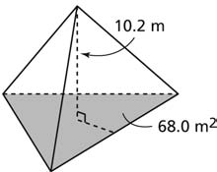

b) 231.2 m3

6. a)

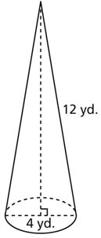

b) 50 yd.3

7. 0.3 m3

8. a) 5 in.3 b) $3.33 c) Approximately 7 in.3

9. a) 4.7 cm b) 10.5 m c) 3.3 m d) 7.4 cm

10. 8.0 cm

11. a) 22.9 kL b) Approximately 8.3 kL

12. 49.6 m3